Lauderdale Profiles

Jessie Ellison HHS ‘10
Campus Staff Campus Outreach
Undergraduate Degree in Organizational Leadership
University of Memphis, Reformed Theological Seminary

Q: How did you select your college major, certification program, or career path?
A: I participated in a scholarship program called the Emerging Leader's Program. In this program, I learned about leadership profiles, how to lead micro and macro events, and more about myself. I also had to volunteer in the city and participate in two campus organizations while serving in leadership positions for those organizations. The program influenced my degree choice. It allowed me to investigate the world and its needs while learning about different cultures and how to love those people. Thus, I cultivated a deep desire with what I was doing in the city of Memphis and the university. I wanted to continue to work with people, but in a service area where I could be used to make a difference. I wanted to help meet the needs of people and provide them with opportunities to make a difference.

Q: What was the biggest influence in your selection of career path?
A: Definitely my faith. When I was graduating college, I had to decide between 4 job offers. All were great and aligned with what I wanted to do on an influential service aspect. What I ended up doing was writing out my vision and values, and I made sure that those values aligned with what I cherished most (walk with Christ and his Word). With that, I looked at each offer, and I chose the one that most matched my values.
Q: If you could go back to high school and select any elective course to take that would have better prepared you for college/career, what would it be?
A: Apologetics
Q: What is your favorite aspect of your job?
A: Teaching women about their identity and worth and training leaders to labor in their career fields. Basically, I get to see lives transformed.
Q: How do you/your company make a positive impact on society/our community?
A: We build leaders on the college campus for the lost world. We do this through discipleship. We have these students for 4-5 years, and then we export them into the community and other places around the world to make a difference for Christ in their occupation.
Q: What’s the most interesting thing you have been able to do in your professional career?
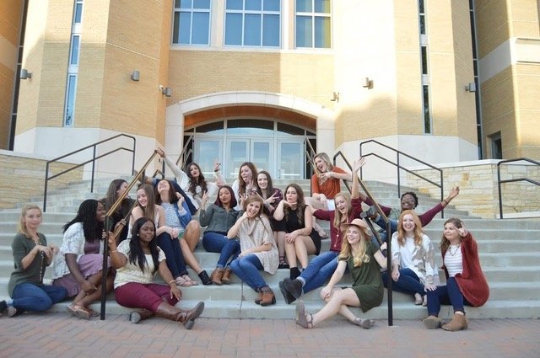
A: I have been able to plan a massive party for 1800 college students, this party changes students' worldview on how to have fun without bad influences. The party is also a blast. Also, I think it is pretty interesting that I have to continue to grow and develop, so that I can reach students and stay relevant to what is influencing and going on in the secular world. Not to mention, my job allows me to travel with the students to places in East Asia and Orlando, FL.
Q: What makes you get up each morning excited about your profession?
A: Knowing that what I do is making a difference for God's glory, and that it is much bigger than myself. I have joy to look forward to, seeing and trusting that people's lives will change and that this is beyond my ability.
Q: What advice would you share with K-12 students who are considering your profession?
A: Evaluate what you value and really define why. You have to have a solid foundation to continue to land on. We deal with people's lives, so it is often messy. But, what do you bank on that will continue to move you forward and give you joy? You have to have deeply rooted convictions and be able to dream, cast vision, and enjoy what you do.
Q: What were some of the jobs you held as a young person (summer jobs, part time work, etc.), before you were on your career path? Did they play any part in your future occupation?
A: My coaches often gave me jobs, so I would work concession stands by serving food and collecting gate money during athletic seasons. Also, I took care of children during YMCA events and tutored at my school. The service aspect definitely did help prepare. Besides leading students, teaching, and planning events, we do things that often go unnoticed. These jobs helped me develop humility in my character and a willingness to get dirty and deal with the details so that the big picture can be moved forward.
Q: What are your plans for the future?
A: I want to continue to give my life away, whatever that looks like. I plan on finishing my seminary degree, being a part of an expansion team as we investigate new college campuses to build laborers on for the world, or going overseas as a counselor.

